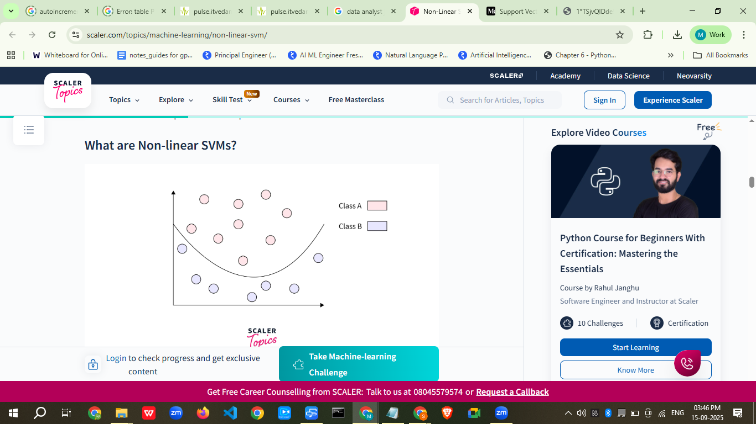
https://www.scaler.com/topics/machine-learning/non-linear-svm/

Lesson Notes – Support Vector Machine (SVM)

Lesson Introduction
Today’s Topics:
- Understanding Vectors
- Decision Boundary
- Support Vectors & Hyperplane
- What is Support Vector Machine?
- Working of SVM
- Kernels and Types of Kernels
- Hard Margin vs Soft Margin
- SVM for Multi-Class Classification
- Practical Example with Dataset
- Business Scenario
- Practice Session
- Case Study
- Assignment & Quiz
https://medium.com/@RobuRishabh/support-vector-machines-svm-27cd45b74fbb

Real-World Hook
- Question to Students:
“When you receive an email, how does Gmail decide if it’s spam or not spam? Or how does a bank’s fraud detection system decide if a transaction is suspicious?”
- Problem:
In real life, we need to separate different classes of data efficiently, even if the boundary between them is not straight.
- Example:
Email spam filter, tumor detection in medical scans, credit card fraud detection.

Introduce Topic as a Solution
SVM is a supervised learning algorithm that helps classify data points by finding the best separating boundary (hyperplane) with the maximum margin between different classes.
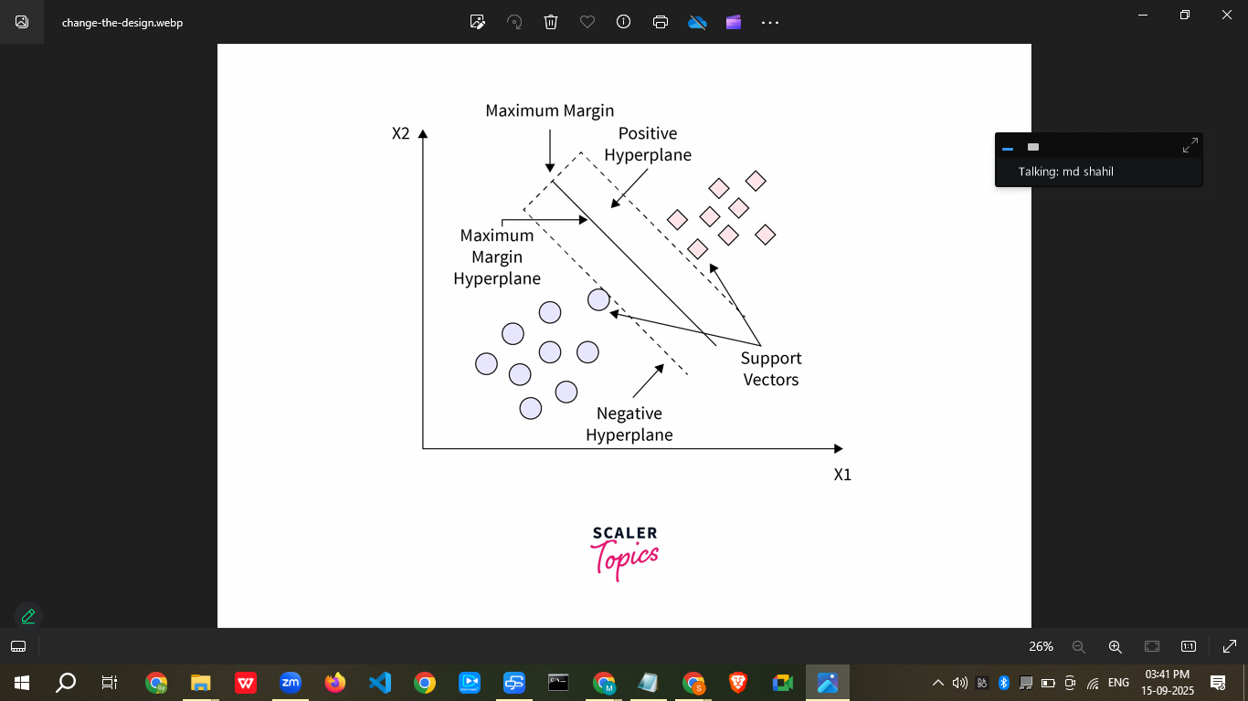
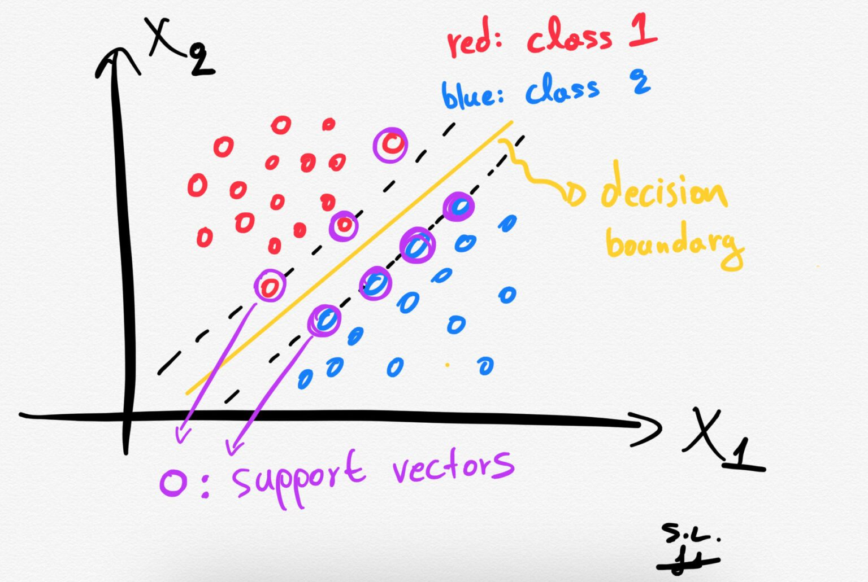

Theory Explanation

1. Understanding Vectors
- What: A mathematical entity with magnitude and direction.
- Why: In ML, features are represented as vectors for computation.
- Example: A person’s attributes (height, weight) → vector [170, 70].
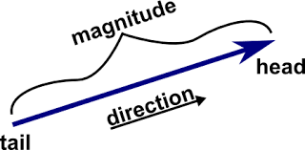

2. Decision Boundary
- What: A line/plane/hyperplane that separates data into different classes.
- Why: Needed to classify new data points correctly.
- When: Used in classification problems.
- How: By finding the optimal hyperplane with maximum margin.
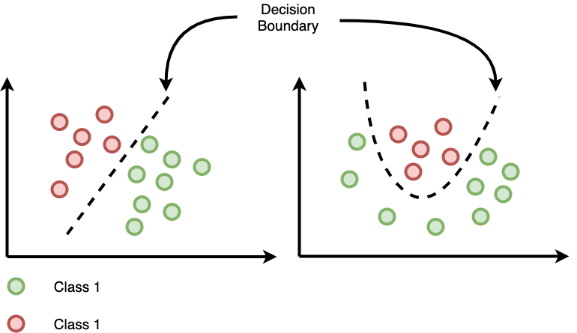

3. Support Vectors & Hyperplane
- Support Vectors: Points closest to the boundary.
- Hyperplane: Mathematical boundary that separates classes.

4. What is Support Vector Machine?
- Definition: A classification algorithm that finds the best hyperplane separating two classes.
- Advantage: Works well with high-dimensional data, effective for complex boundaries.
- Disadvantage: Slow for very large datasets.

5. Working of SVM
- Plot data in n-dimensional space.
- Choose a hyperplane that separates classes with the maximum margin.
- Use kernels if data is not linearly separable.
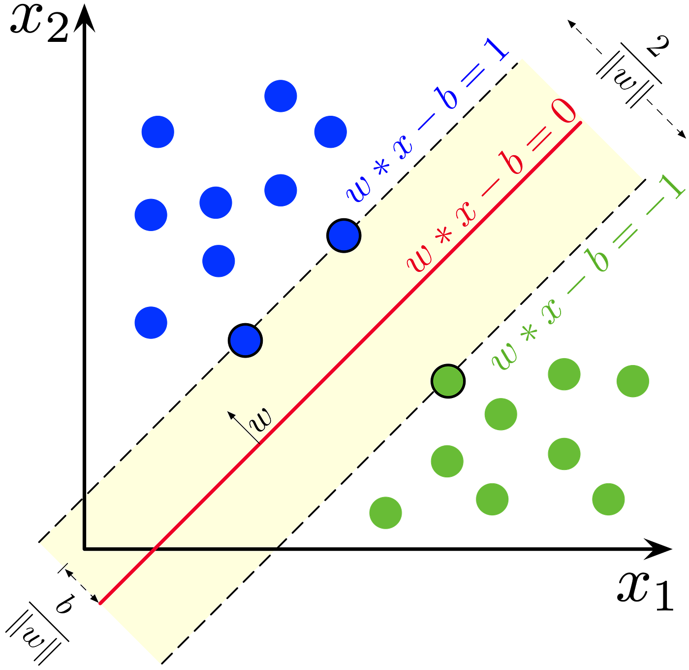

6. Kernels and Types
In a Support Vector Machine (SVM), a kernel is a function that maps input data into a higher-dimensional space, enabling the algorithm to find a linear decision boundary for non-linearly separable data.
- Linear Kernel – Straight boundary.
- Polynomial Kernel – Curved boundary.
- RBF Kernel – Handles complex boundaries.
- Sigmoid Kernel – Similar to neural networks.
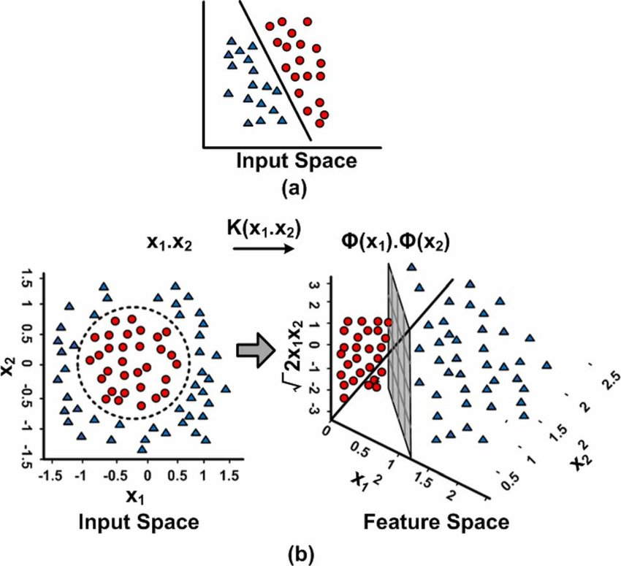

The Kernel Trick
A method where Non-Linear data is projected onto a higher dimension space such that it is easier to classify the data where it could be linearly divided by a plane. The trick is that we are not transforming the data points. We are achieving this mathematically for our convenience.

Linear SVM vs Non-Linear SVM
Linear SVM | Non Linear SVM
The data points are separated using a single line | The data points are hard to separate, so other shapes are used as a decision boundary.
Data is classified with the help of a hyperplane. | Kernels are used to classify data points.
difficult to classify more than two labels. | Used for classifying more than two labels.

Conclusion
The key takeaways from this article are:-
- There are two types of SVM: linear and non-linear, they are used depending on the type of data.
- Non-linear SVM uses the Radial Basis Function Kernel that takes the data points to a higher dimension so that they are linearly separable in that dimension, and then the algorithm classifies them.
- Radial Basis Function Kernel is implemented using sklearn's SVC model.
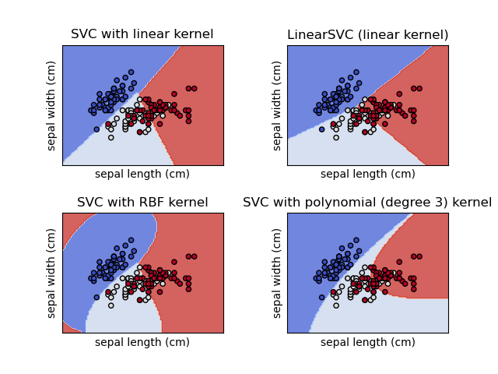

7. Hard Margin vs Soft Margin
- Hard Margin: No misclassification allowed.
- Soft Margin: Some misclassification allowed to handle noise.

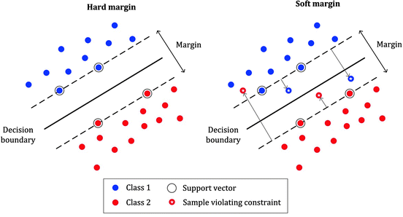

8. Multi-Class Classification
- One-vs-One (OvO) and One-vs-Rest (OvR) strategies.

Limitations
- Memory-intensive for large datasets.
- Slower for huge datasets.
- Less effective for overlapping classes.
Overcoming Limitations:
- Use approximate SVM methods.
- Dimensionality reduction before training.
- Switch to faster algorithms for large datasets.

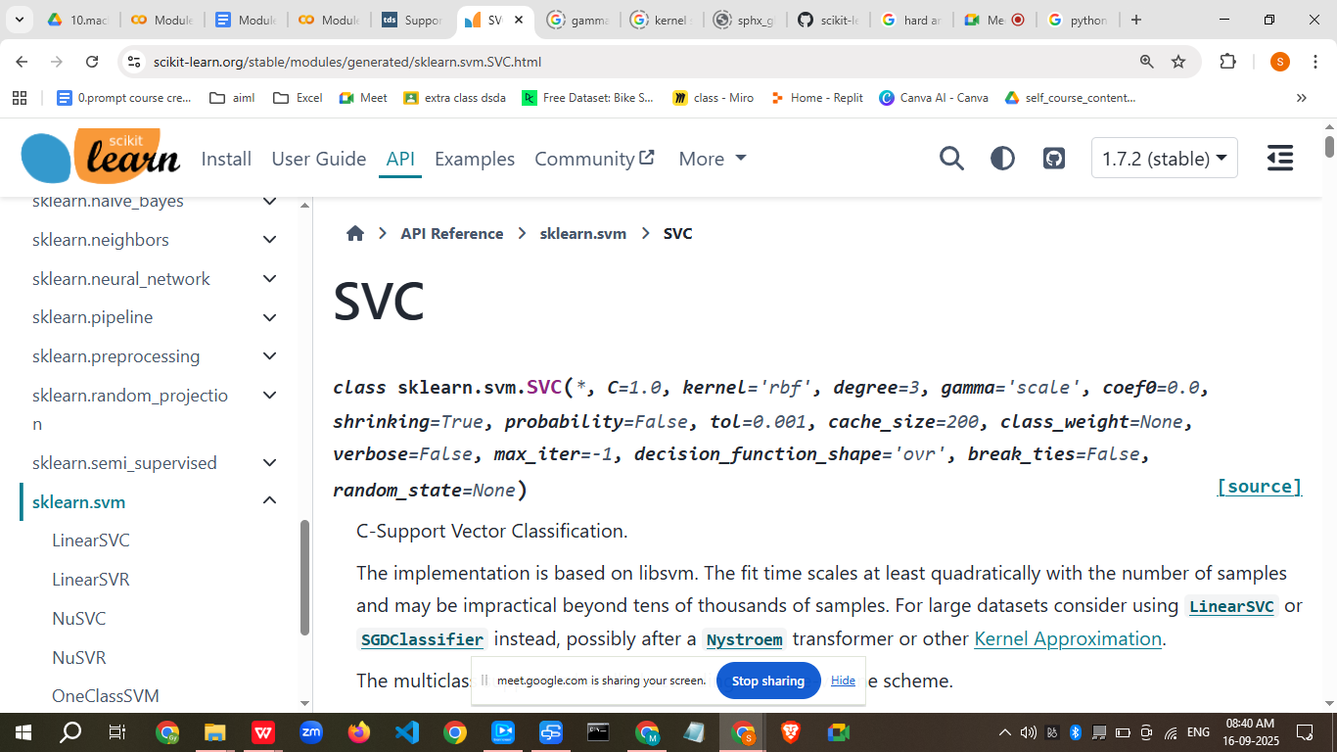

====================================================================
The gamma parameter in Support Vector Machines (SVMs) and related models (like SVC, SVR, OneClassSVM) controls the influence of individual training samples on the decision boundary. It is a kernel coefficient relevant for 'rbf', 'poly', and 'sigmoid' kernel functions.

Here's a breakdown of its possible values:
- 'scale' (default in newer scikit-learn versions): When gamma='scale', the value used for gamma is calculated as 1 / (n_features * X.var()), where n_features is the number of features in the dataset and X.var() is the variance of the features. This scaling aims to make the gamma value more robust to the scale of the input data.
- 'auto' (default in older scikit-learn versions): When gamma='auto', the value used for gamma is 1 / n_features. This approach considers only the number of features, potentially making it less sensitive to the data's distribution compared to 'scale'.
- float: You can also specify a specific non-negative floating-point value for gamma. This allows for fine-tuning the model's sensitivity to individual data points.
Impact of gamma:
- High gamma value: A high gamma value implies that individual training samples have a far-reaching influence, leading to a more complex decision boundary that tries to fit each data point closely. This can result in overfitting, especially with noisy data.
- Low gamma value: A low gamma value indicates a smaller influence of individual training samples, leading to a smoother and simpler decision boundary. This can result in underfitting if the model is too generalized to capture the underlying patterns in the data.
Choosing the right gamma:

The optimal value for gamma often depends on the specific dataset and problem. Techniques like grid search or cross-validation are commonly used to find the best gamma value that balances bias and variance in the model.

AI responses may include mistakes.

====================================================================

Practical Example (Dataset – 50 points)
Dataset – Student Exam Scores (Pass/Fail)
Hours_Studied | Practice_Tests | Result
2 | 1 | Fail
5 | 2 | Pass
... | ... | ...
(50 rows total)
Code Example:
from sklearn import datasets
from sklearn.model_selection import train_test_split
from sklearn.preprocessing import StandardScaler
from sklearn.svm import SVC
from sklearn.metrics import accuracy_score

# Load dataset
X, y = datasets.make_classification(n_samples=50, n_features=2, n_informative=2,
n_redundant=0, n_classes=2, random_state=42)

# Split data
X_train, X_test, y_train, y_test = train_test_split(X, y, test_size=0.2, random_state=42)

# Scale data
scaler = StandardScaler()
X_train = scaler.fit_transform(X_train)
X_test = scaler.transform(X_test)

# Train SVM
model = SVC(kernel='linear', C=1)
model.fit(X_train, y_train)

# Predict
y_pred = model.predict(X_test)
print("Accuracy:", accuracy_score(y_test, y_pred))

Business Scenario
- Company: Credit Card Fraud Detection System
- How Used: SVM helps detect fraudulent transactions by separating legitimate and suspicious transactions in a feature space.

Practice Session
- Train SVM with linear kernel and measure accuracy.
- Change kernel to rbf and compare results.
- Adjust C value and see how decision boundary changes.
- Apply SVM to Iris dataset.
- Try multi-class classification with OvR strategy.

Case Study
Problem: Classifying emails as spam or not spam.
Solution:
- Extract features from emails.
- Use SVM with RBF kernel.
- Achieved 97% accuracy in separating spam from ham emails.

Assignment
- Build an SVM model for breast cancer detection using scikit-learn dataset.
- Test different kernels and compare results.

Quiz
- What does SVM stand for?
- Name 2 types of kernels.
- What is the difference between hard and soft margin?

Recap
- SVM finds the optimal hyperplane with the largest margin.
- Works well for high-dimensional and non-linear problems.
- Kernels help in transforming data for better separation.

Streamlit Interactive App
import streamlit as st
import pandas as pd
from sklearn.model_selection import train_test_split
from sklearn.preprocessing import StandardScaler
from sklearn.svm import SVC
from sklearn.metrics import accuracy_score, classification_report, confusion_matrix
import seaborn as sns
import matplotlib.pyplot as plt

st.title("🎯 Interactive SVM Classifier")

uploaded_file = st.file_uploader("Upload CSV file", type=["csv"])
if uploaded_file:
df = pd.read_csv(uploaded_file)
st.write(df.head())

target_col = st.selectbox("Select Target Column", df.columns)
feature_cols = [col for col in df.columns if col != target_col]

X = df[feature_cols]
y = df[target_col]

test_size = st.slider("Test Size", 0.1, 0.5, 0.2)
X_train, X_test, y_train, y_test = train_test_split(X, y, test_size=test_size, random_state=42)

scaler = StandardScaler()
X_train = scaler.fit_transform(X_train)
X_test = scaler.transform(X_test)

kernel = st.selectbox("Kernel", ["linear", "poly", "rbf", "sigmoid"])
C = st.slider("C (Regularization)", 0.01, 10.0, 1.0)

model = SVC(kernel=kernel, C=C)
model.fit(X_train, y_train)
y_pred = model.predict(X_test)

st.write("Accuracy:", accuracy_score(y_test, y_pred))
st.text(classification_report(y_test, y_pred))

cm = confusion_matrix(y_test, y_pred)
fig, ax = plt.subplots()
sns.heatmap(cm, annot=True, fmt="d", cmap="Blues", ax=ax)
st.pyplot(fig)

